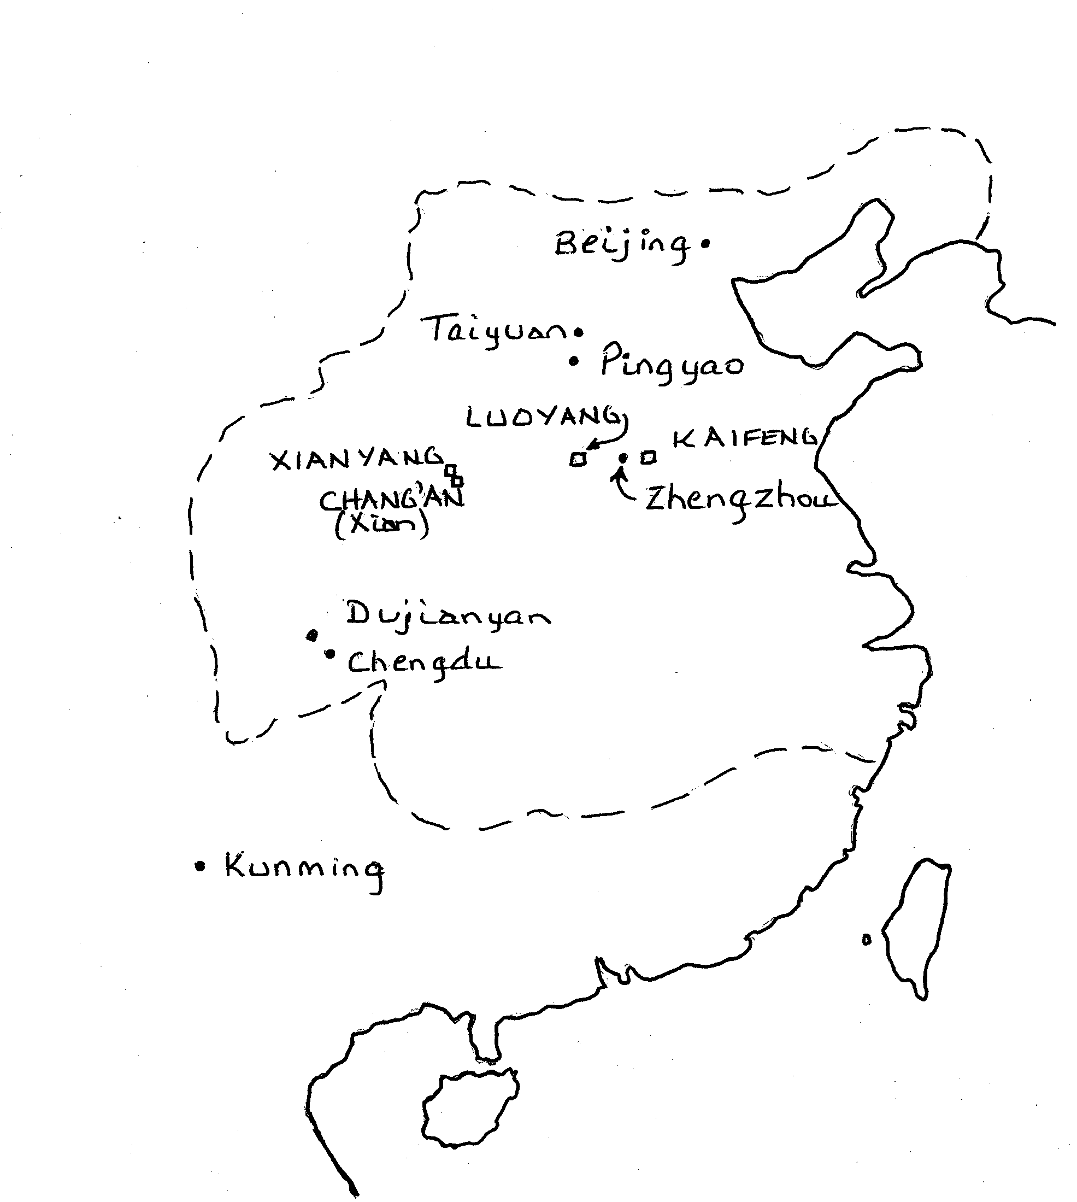
N    Not to Scale | Sketch Map of Ancient China  Extent of Qin and Han Dynasties
N    Not to Scale | ----- Boundary of Empires
N    Not to Scale | - Capital Cities of Qin and Han Dynasties  - Cities mentioned on Website

